DIGITAL BOOK SYSTEM

Catalog
DIGITAL BOPOK SYSTEM. 1
I. Introduction. 1
II. Problem and Solution 1
Problem Statement 2
Solution: 2
Impact and Value Proposition 2
III. System Design and Architecture 2
Architecture Diagram. 2
Architectural Components 3
IV. Data Model and Process Flow 3
On-chain Data Model 3
Core Workflow: Book Registration 4
V. Testing, Risks, and Future Work 4
Test Summary 4
Risks & Mitigations 5
Limitations 5
Future Work and Expansion 5
SYSTEM MANUAL. 6
1. Access and Control (Login & Dashboard) 6
2.Incident Tracking and Reporting 7
3.Legal Documentation and Charge Sheet Generation 9
4.Final Charge Sheet Output 10

I. Introduction.
This project proposes a novel approach to digital content management by replacing centralized server reliance with a distributed blockchain ledger.
The core issue—lack of verifiable ownership and content integrity in traditional digital books—is solved by tokenizing book ownership (Non-Fungible Tokens or similar structures) and utilizing cryptographic hashing to guarantee content authenticity.
The resulting system promises enhanced trust, secure peer-to-peer sharing capabilities (lending), and transparent royalty distribution for authors.

II. Problem and Solution

Problem Statement
Traditional digital book systems rely on centralized servers, creating single points of failure that compromise user control, content integrity, and transactional transparency.
Vulnerability: Centralized databases are susceptible to data breaches,unauthorized modifications, and censorship.
- Ownership ambiguity: Users only possess a license to read, not true verifiable ownership, limiting secondary market potential or lending rights.
- Lack of transparency: Authors and publishers cannot reliably track the true usage, distribution, or resale history of their content.

Solution:
The Digital Book System leverages a smart contract platform (e.g., Ethereum, Polygon) to establish immutable, verifiable, and programmable ownership rights.
- Verifiable Ownership: Each digital book copy is represented by a unique, transferable token (e.g., an ERC-721 NFT or a custom token standard) stored on the blockchain. This token proves who the current, legitimate owner is.
- Immutable Integrity: When a book is uploaded, its content is stored on decentralized storage (IPFS), and a unique cryptographic hash is written permanently to the blockchain ledger. Any subsequent tampering with the file is immediately detectable because the file hash will no longer match the on-chain record.
- Programmable Access: Smart contracts define and automatically enforce rules for access (only the owner can unlock), transfer (sales), and temporary sharing (lending).

Impact and Value Proposition
Stakeholder | Benefits
Readers/Owners | True verifiable ownership, secure lending/sharing rights, guaranteed content authenticity.
Authors/Publishers | Transparent, automated royalty payments, verifiable usage analytics, tamper-proof distribution.
System | High integrity, censorship resistance, reduced operational risk due to decentralization.

III. System Design and Architecture
The system is split into three interacting layers: the Presentation Layer (Front-end), the Business/Logic Layer (Smart Contracts & Middleware), and the Storage Layer (Blockchain & Off-chain).

Architecture Diagram.



Architectural Components
Front-end (Presentation Layer):
Function: Web or mobile interface for user interaction (registration, browsing, reading, managing owned books).
Interaction: Communicates with the Smart Contract layer via a Web3 provider (like MetaMask) to initiate transactions (purchase, transfer, lend) and queries (checking ownership).
Back-end / Logic Layer (Smart Contracts):
- Book Registry Contract: Manages the creation of BookIDs and stores the essential immutable data (AuthorID, initial HashPointer).
- Ownership Contract (Token): The core contract that implements the ownership standard (e.g., NFT). It handles the OwnerID and enforces transfer rules.
- Access/Lending Contract: Contains the logic for conditional access. When a book is lent, this contract temporarily grants the borrower a time-bound decryption key or access permission, revoking it automatically upon expiry.

Off-chain Storage (IPFS/Distributed Storage):
- Function: Stores the actual, large book files. The content is stored encrypted.
- Interaction: The Smart Contract holds the HashPointer (the unique IPFS content address) and manages the distribution of the decryption key to the legitimate owner/borrower.
Blockchain Network (Immutable Ledger):
Function: Provides the immutable, decentralized, and globally synchronized ledger for all transaction and ownership proofs.

IV. Data Model and Process Flow

On-chain Data Model
The system uses minimal data on-chain to maximize efficiency and minimize gas fees, relying on the hash pointer for content verification.
Field | Type | Description
BookID | uint256 | Unique identifier for the book/token.
AuthorID | address | Wallet address of the original author/publisher for royalty tracking.
OwnerID | address | Wallet address of the current holder of the book token.
HashPointer (IPFS CID) | string/bytes32 | Cryptographic content identifier (CID) linking to the encrypted book file on IPFS. This is the integrity check.
Permissions List | mapping | Defines current access rights (e.g., can_read: true, can_lend: false).
History Log | event / array | Timestamped record of ownership transfers.

Core Workflow: Book Registration
- Author Action: Author encrypts the book file, uploads the encrypted file to IPFS, and obtains the unique HashPointer (CID).
- Transaction: Author calls the registerBook function on the Smart Contract, passing metadata and the HashPointer.

On-Chain Result: The contract creates a new BookID, links it to the AuthorID and HashPointer, and issues the first token (ownership) to the Author. This event is immutable.

V. Testing, Risks, and Future Work

Test Summary
Testing focuses on verifying the integrity and execution of the core contracts.
Deployment Tests: Verify successful deployment of all smart contracts (Book Registry, Ownership, Access) onto the target blockchain (e.g., using Ganache/Truffle for local testing).

Functional Tests:
- Book Lifecycle: Upload, ownership transfer (sale), and lending/return cycles.
- Access Control: Verification that only the wallet listed as the OwnerID can retrieve the decryption key from the Access contract.

- Integrity Check: Attempting to register a book with a modified hash fails.
- Security Tests: Stress testing denial-of-service attack vectors and attempting unauthorized calls to restricted functions (e.g., minting new tokens without authorization).

Risks & Mitigations
Risk | Description | Mitigation Strategy
High Gas Fees | Transaction costs on the mainnet could discourage frequent lending/transferring. | Utilize Layer-2 scaling solutions (e.g., Optimism, Arbitrum) or a delegated Proof-of-Stake chain with low transaction costs.
Privacy Leakage | Book metadata (titles, authors) stored on-chain is public. | Implement zero-knowledge proofs (ZKPs) for proving ownership or access rights without revealing all metadata, or encrypt sensitive metadata fields.
Lost Wallet Keys | Loss of private keys leads to permanent loss of book access. | Integrate a Social Recovery mechanism where trusted friends/institutions can help recover the account, or use a multi-signature contract.

Limitations
- User Blockchain Literacy: Requires a learning curve for users unfamiliar with wallets, gas fees, and key management.
- Off-chain Redundancy: While IPFS is decentralized, ensuring long-term pinning (availability) of the book file requires reliable services (e.g., Filecoin, Pinata).
- High Upfront Costs: Initial contract deployment and book registration costs (gas fees) can be substantial.

Future Work and Expansion
The proposed system is a foundation for a fully decentralized marketplace and ecosystem.
- Decentralized Identity (DID) Integration: Use standards like W3C DIDs to allow authors to verify their identity without relying on a central authority, enhancing trust.
- Recommendation Engine: Develop a decentralized, privacy-preserving recommendation engine based on encrypted reading history, rewarding users with tokens for sharing anonymized data.
- Automated Royalty Distribution: Program the smart contract to automatically split payment upon purchase or resale, instantly transferring pre-defined percentages to the AuthorID, PublisherID, and previous OwnerID (for royalties on secondary sales).
- Analytics Dashboards: Build a front-end interface for authors to easily view on-chain metrics such as sales volume, transfer history, and active lending contracts.

SYSTEM MANUAL.

1. Access and Control (Login & Dashboard)
Login Screen: This shows the entry point of the application, titled "Digital Occurrence Book." It clearly outlines the security requirement for users to sign in with a Username/Email and Password, confirming the system uses access control.
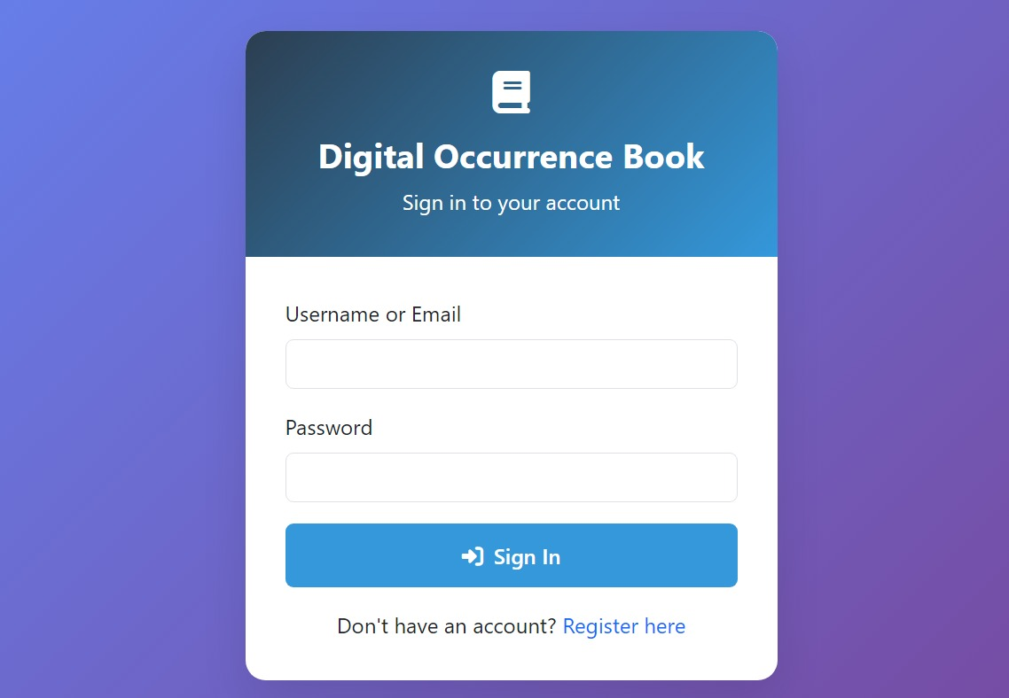
Admin Dashboard: This is the high-level control panel. It aggregates key metrics (4 Total Reports, 3 Resolved, 4 Reporters), providing administrators with an immediate, statistical overview of the system's health and operational throughput
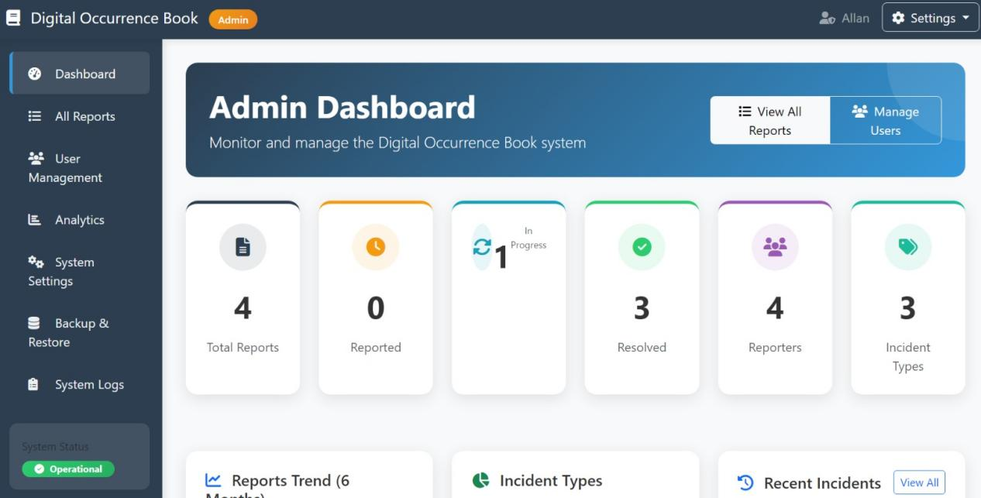

2.Incident Tracking and Reporting
All Reports List: This is the core table where all incidents are logged. It demonstrates the ability to track essential data points for each incident: a unique ID, Type (e.g., Assault, Theft), Description, Location, the Reporter, Incident Date, and a color-coded Status (In Progress, Resolved). The inclusion of Actions (View, Edit, Delete) confirms management capabilities.
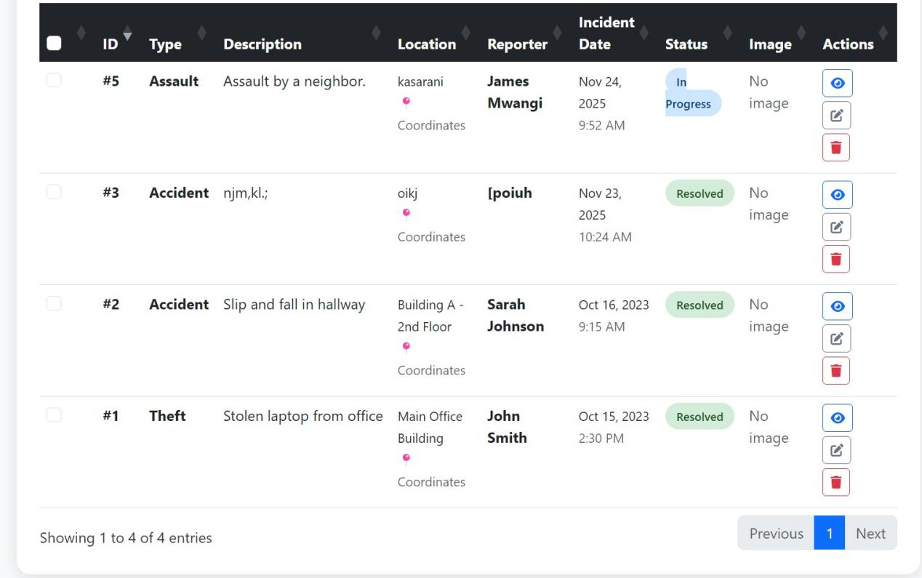
Report Filtering: This image highlights the crucial search and filter functionality. It shows users can query the reports based on Status, Incident Type, Reporter, and a Date Range, which is essential for investigative analysis and efficient data retrieval.

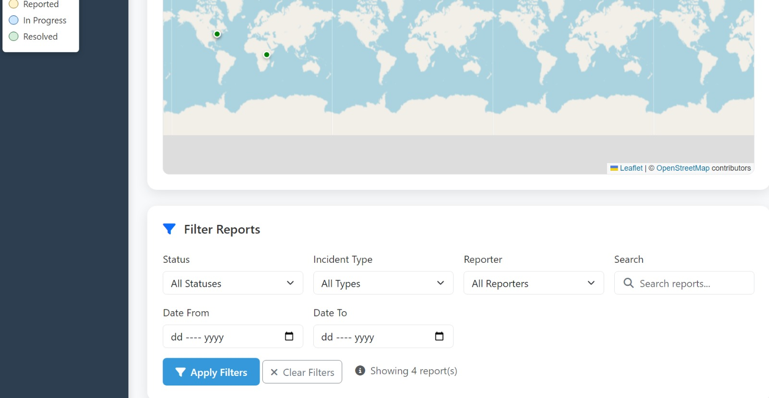
Incident Detail View: These images show a deep dive into a specific case (Incident Report ). They detail Incident Information (Type, Location, Date/Time), Reporter Information, and a Report Timeline—which logs when the report was created and last updated. This guarantees a verifiable audit trail for the case.

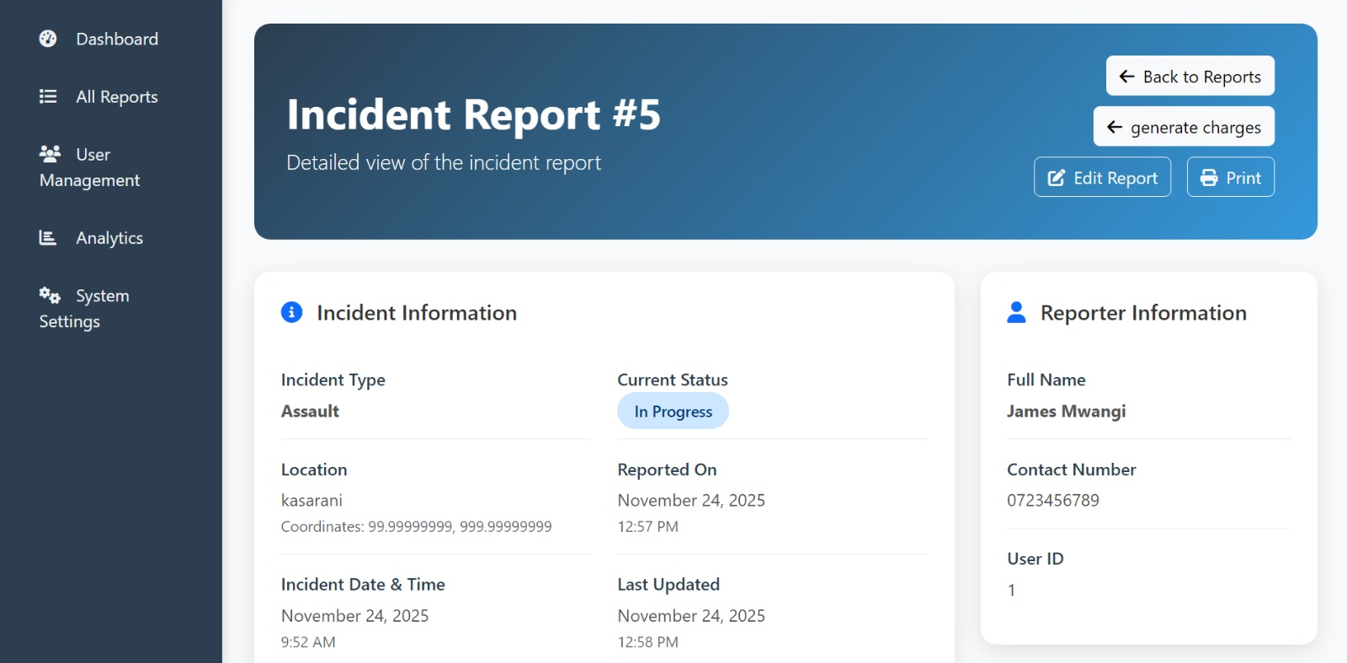

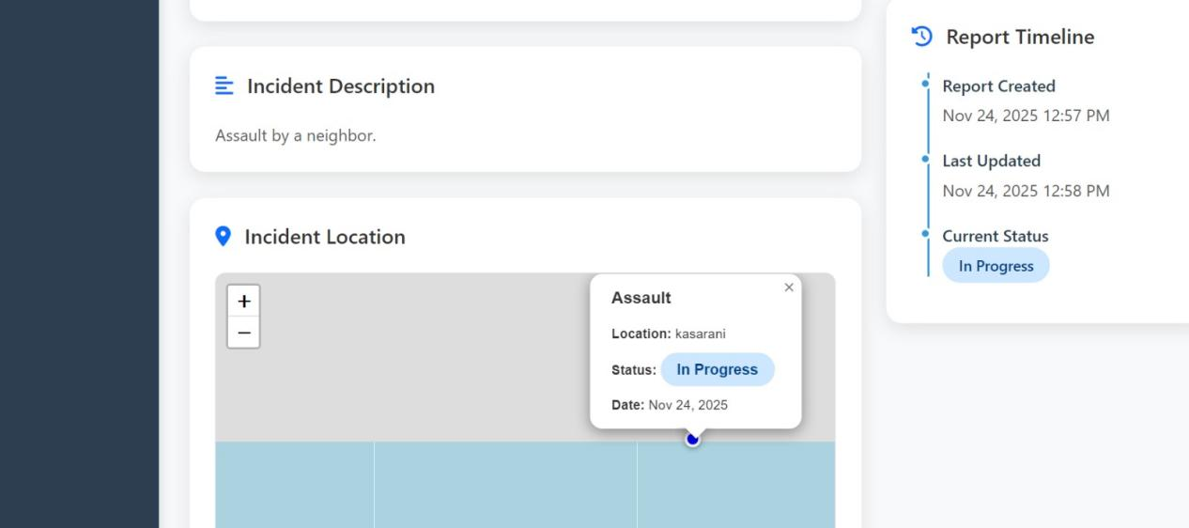

3.Legal Documentation and Charge Sheet Generation
Charge Sheet Form: These images confirm the system’s primary legal function: generating formal Charge Sheets. The interface guides the user through linking the document to a specific Incident and recording mandatory legal details, including:
Charge Sheet Number and Issuing Officer.
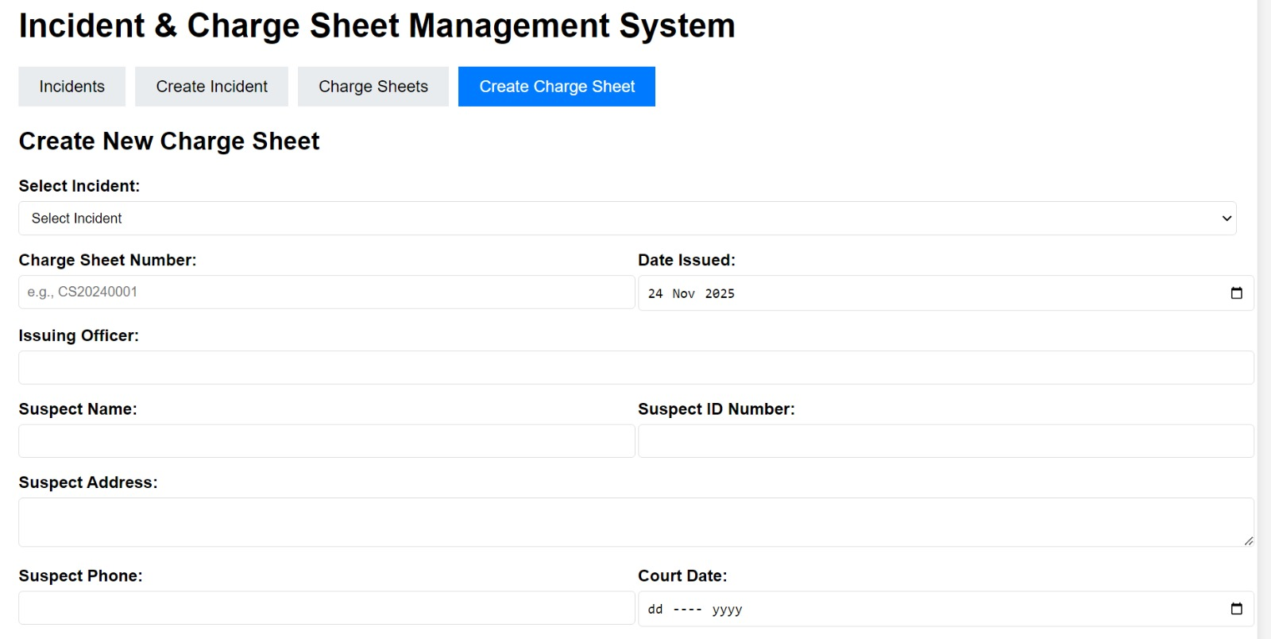

Suspect Information.
Charges, Facts of Case, and Evidence.

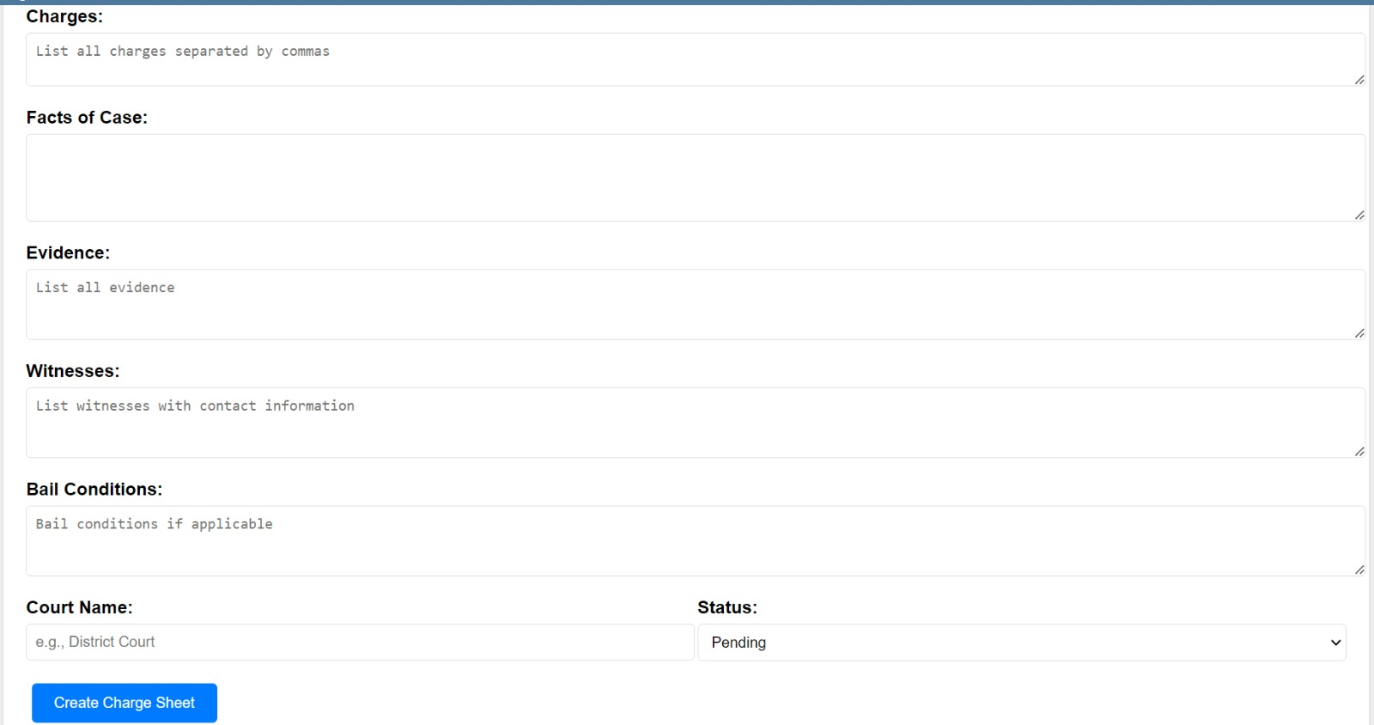

Bail Conditions.
The final output can be saved with a specific Status (e.g., Pending), ensuring proper case management continuity.

4.Final Charge Sheet Output
These images represent the output phase of the workflow (the "Print" function), confirming that all data entered in the creation form is compiled into a professional document.

Header, Charge Sheet Details, Related Incident, Suspect Information
Confirms the header is clearly titled CHARGE SHEET and includes the unique Charge Sheet Number (01) and Date Issued (2025-11-24). It successfully links back to the Related Incident (e.g., Accident) and lists the full Suspect Information (Name, ID, Phone).
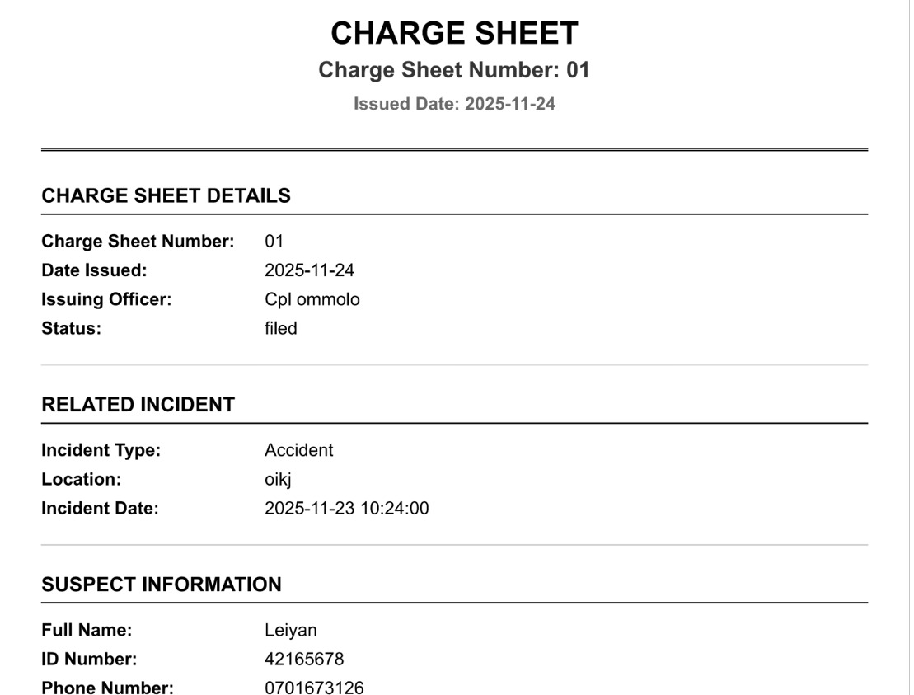

Charges, Facts of the Case, Evidence
This section displays the critical legal documentation fields: The specific CHARGES filed ("drunk driving"), the narrative FACTS OF THE CASE ("Guilty"), and the logged EVIDENCE. This validates that the system maintains all data required for court submission.
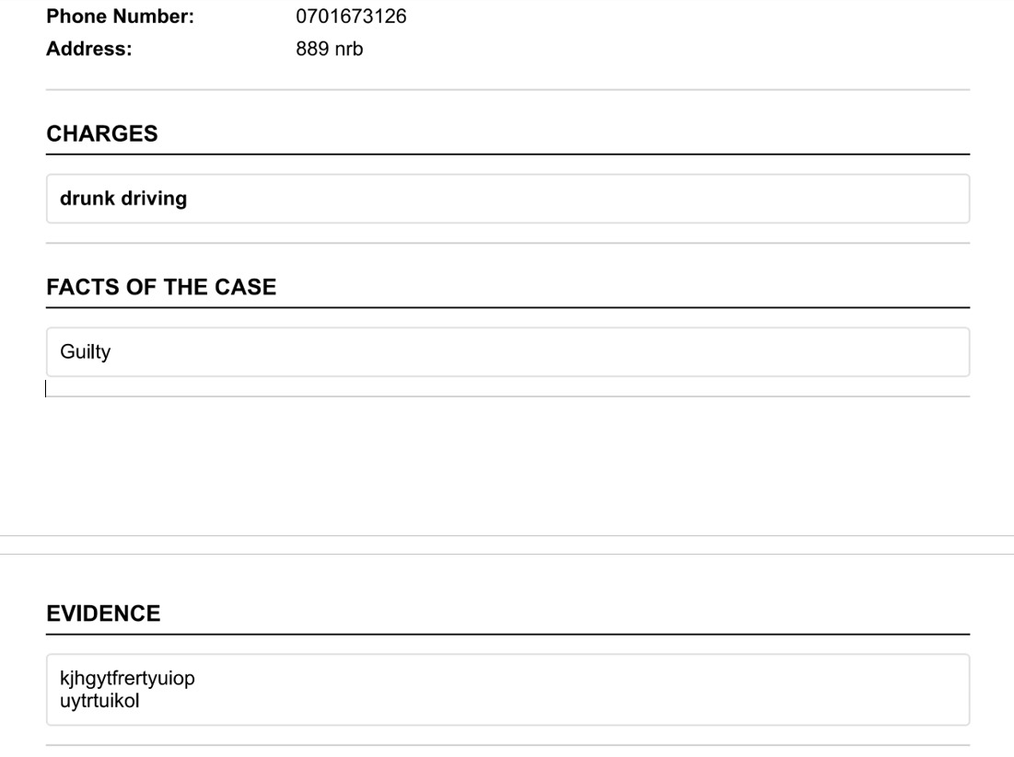

Witnesses, Bail, Court Information, Signatures
This concludes the document, showing the list of WITNESSES, the imposed BAIL CONDITIONS ("Flight risk"), and the COURT INFORMATION (Name: kibra, Date: 2025-11-26). Crucially, it includes dedicated lines for Issuing Officer Signature and Suspect Signature, verifying the document is ready for official sign-off and physical recording.
